In this example we show how to make a field mandatory via Error message and automatically populate a field in t-code IE01 – Maintain Equipment (PM transaction)

Open t-code SMOD and check the documentation to find the exception POSTING_NOT_ALLOWED_EX to be used to display the error message:

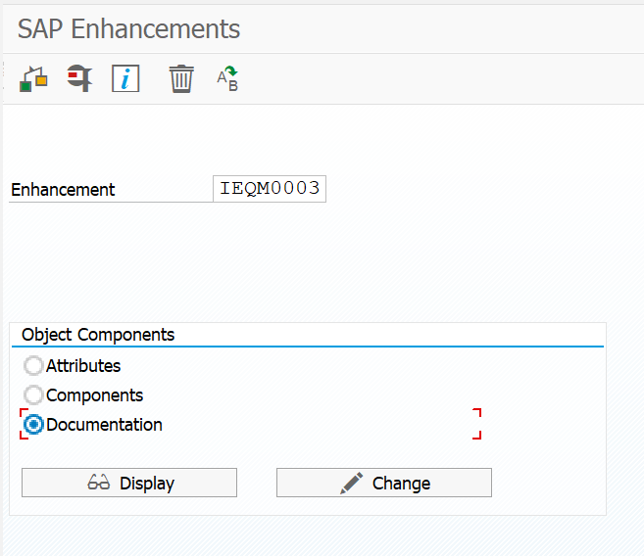

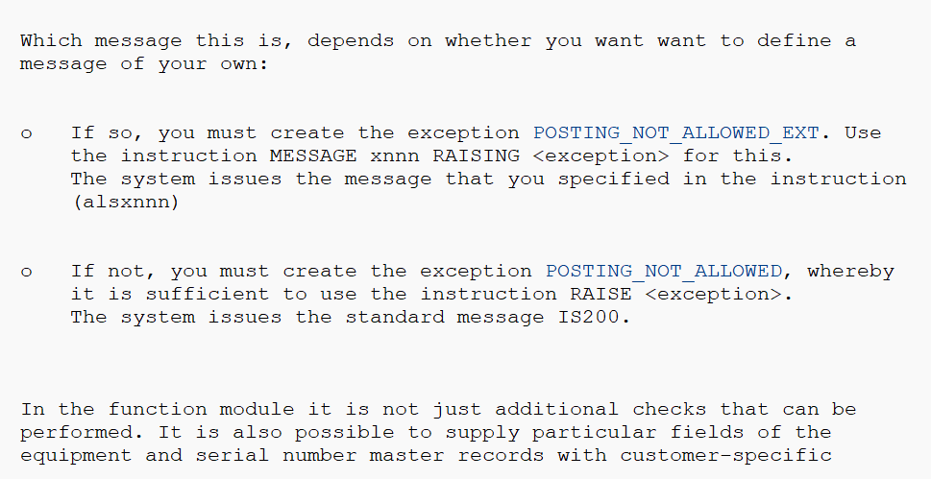

Now access the Components:

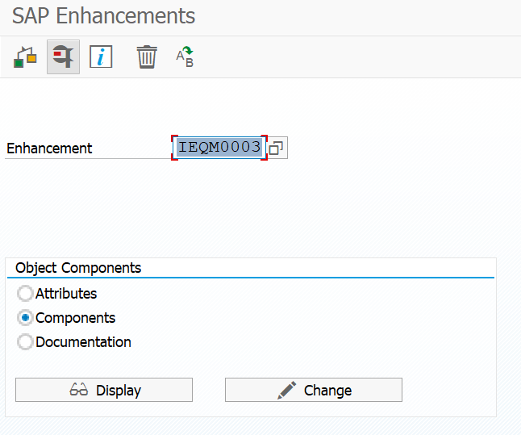

Double-Click program name:

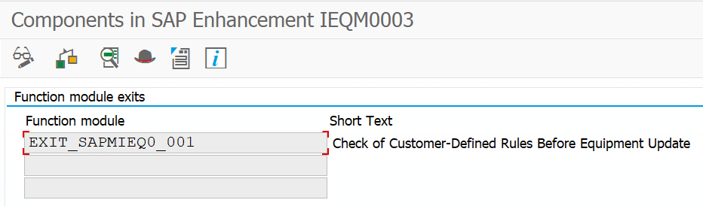

Go to tab IMPORT to find the relevant field to verify mandatory entry. I choose field DATA_ILOA-SWERK.

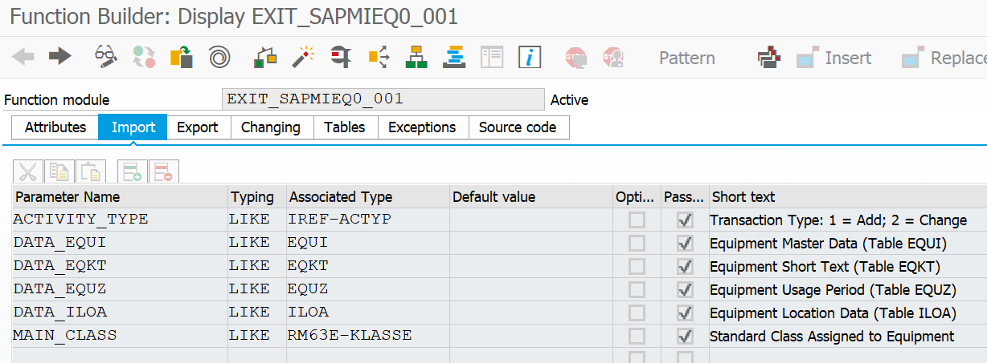

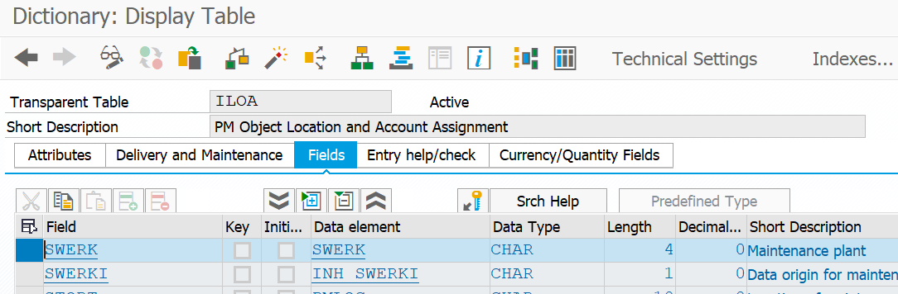

Double-click the Include and code

